Nutrition Jeopardy
MA Senior Nutrition Program | Standardized Nutrition Education | Fall 2026
Program Overview
Jeopardy is being used as an interactive format for statewide nutrition education. You may choose to use the electronic game or a low-tech poster-board version, depending on available technology.

Implementation Guidance
- Questions were collected from program dietitians at the December 2025 meeting. You may also create your own Jeopardy game and questions.
- If feasible, small prizes or raffle tickets may be awarded to winners or distributed during the game.
- Participants may use a paddle or raise their hand to indicate they are ready to answer.
- A general evaluation will be used instead of a pre/posttest. Please submit responses to AGE when requested using the Excel form provided.

Method 1: Screen and Internet Connection
AGE game: https://jeopardylabs.com/play/nutrition-jeopardy-3001
JeopardyLabs: https://jeopardylabs.com/
1. Open the AGE game. Use “Reset” to restart the game as needed. To customize it, create your own game or save an editable copy and create a new password when prompted.
2. Select the number of teams and click “Continue” to begin.
3. Participants who raise their hand or paddle first may be selected to answer. Select a dollar value to display the question, then press the spacebar to display the answer.
4. The game includes five categories with five questions each. Use the + and - controls to track team scores at the bottom of the screen.

Electronic Game Reference
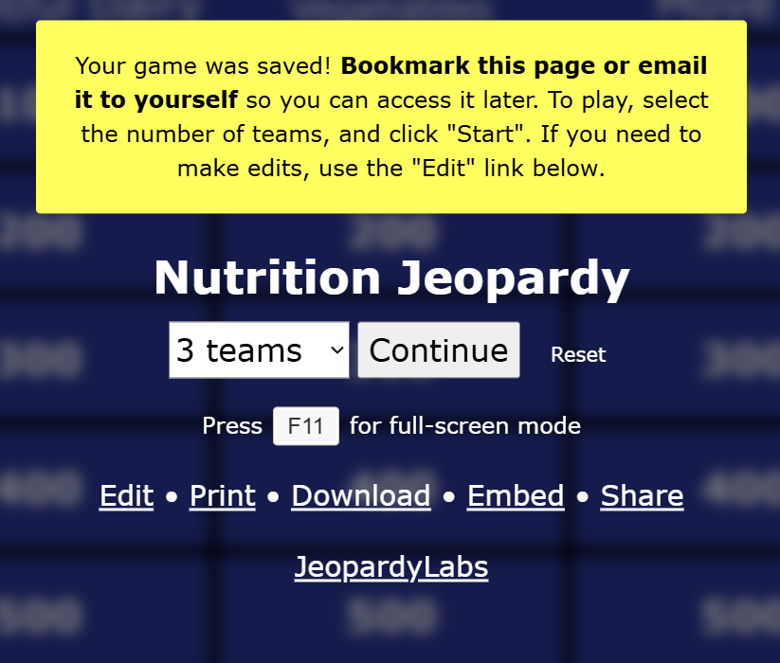 | 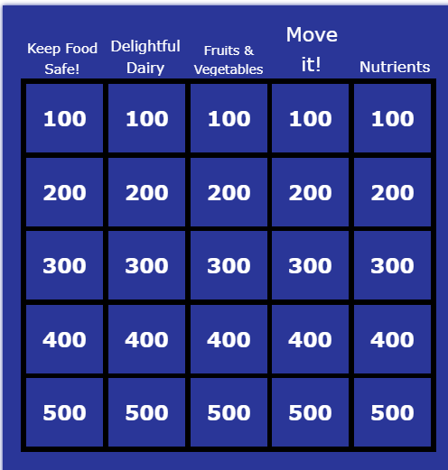
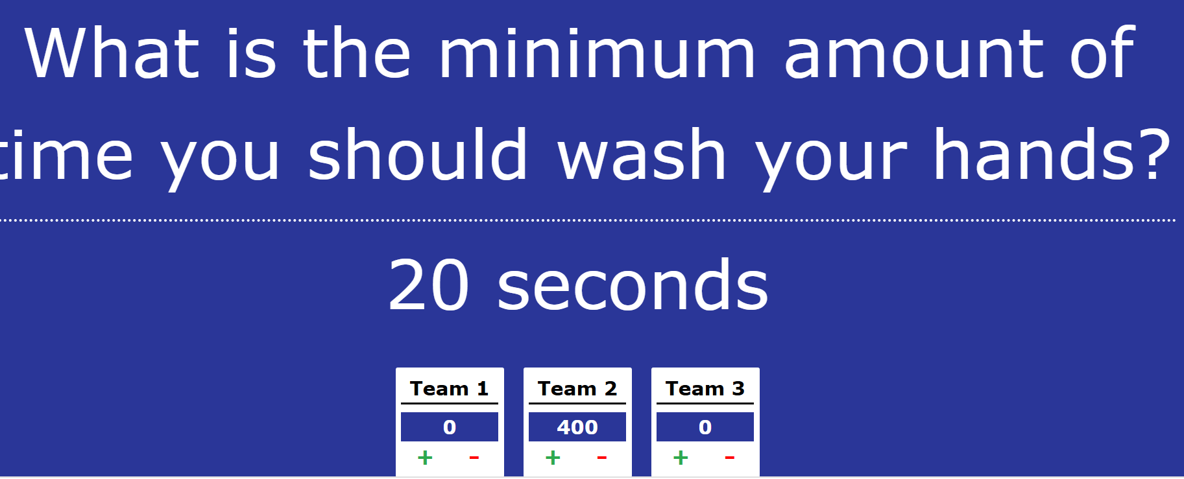

Method 2: Poster Board
Print the questions on 3 x 5 index cards and place them in envelopes labeled with the corresponding dollar values/categories. Participants select a category and dollar amount; the dietitian reads the matching question. Participants who raise their hands or paddles first should be selected to answer.
Example courtesy of Dawn DiMarco, Bristol Aging and Wellness.
